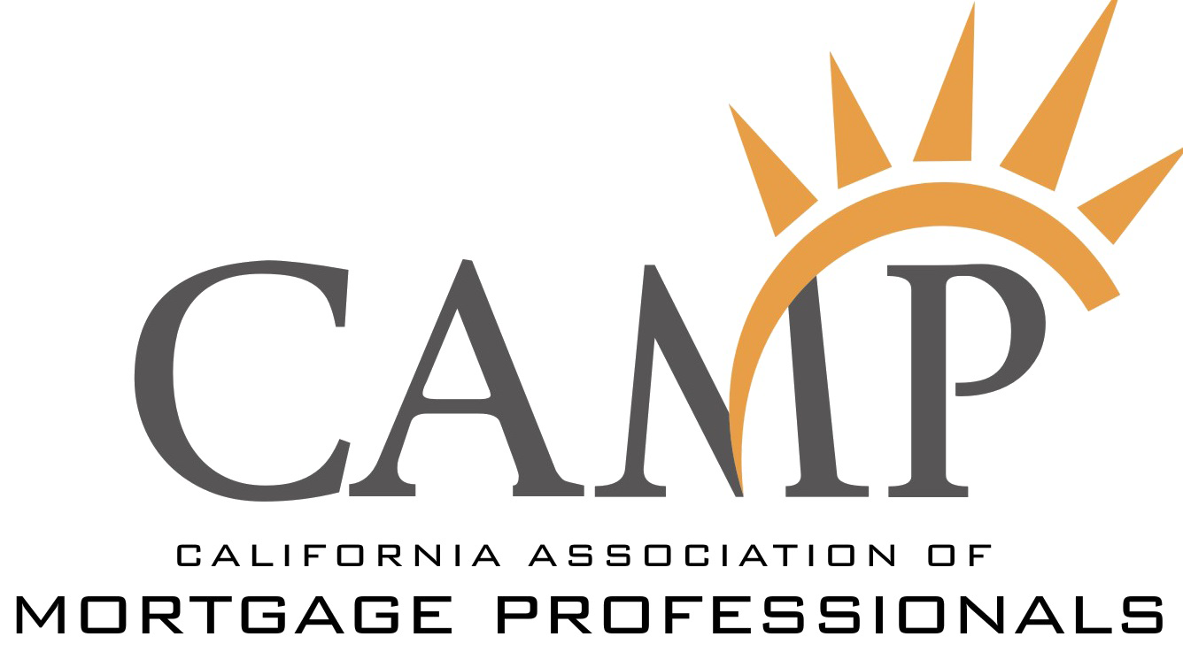
CAMP State Lobby Day

Legislative Meetings 101:
Do’s and Don’ts

What You SHOULD DO

- Be prompt
- When introducing yourself, include the geographic area where you do business
- Give the member your “leave behind” and business card
- Ask the member/staff for their card
- Be polite and pleasant
- Offer to be of further assistance and to serve as a resource
- Thank the member/staff for their valuable time and remember to send a short thank you letter when you get home

What You SHOULD NOT DO

- Be late
- Be impatient
- Assume the member will know or remember you
- Waste the member’s time
- Give the member too many materials
- Underestimate the influence of the staff
- Be rude, argumentative or abrasive
(today’s opponent may be tomorrow’s ally)
- Make demands or threaten the member
- Mention any CAMP PAC contributions, personal contributions or other planned or previous financial support of the member

